# Problem 1.1

class shape:  
  
 def setSides(self):  
 msg = "Enter sides of " + self.__class__.__name__ + " seperated by Comma : "  
 a = input(msg).split(",")  
 self.sides = a  
  
  
 def getSides(self):  
 return self.sides  
  
  
class triangle(shape):  
  
 def areaTriangle(self):  
  
 allsides = super().getSides()  
  
 side1 = int(allsides[0])  
 side2 = int(allsides[1])  
 side3 = int(allsides[2])  
  
 s = (side1+side2+side3)/2  
  
 area = (s*(s-side1)*(s-side2)*(s-side3))**0.5  
 return area  
  
class square(shape):  
  
 def areaSquare(self):  
 allsides=super().getSides()  
 side1 = int(allsides[0])  
 area = side1 * side1  
 return area  
  
  
  
tri=triangle()  
tri.setSides()  
print("Area of triangle = ",tri.areaTriangle())  
  
sq=square()  
sq.setSides()  
print("Area of Square = ",sq.areaSquare())

Output

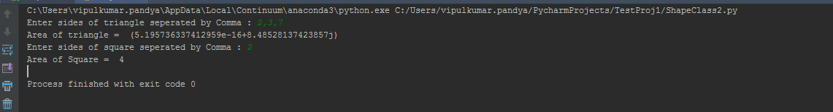

# Problem 1.2

def filter_long_words(lst=[],n=0):  
 longwrd=[wrd for wrd in lst if len(wrd) > n ]  
  
 return longwrd  
  
  
a = input("Enter a sentense : ").split(" ")  
b = input("Enter lenght of word : ")  
print(filter_long_words(a,int(b)))

Output

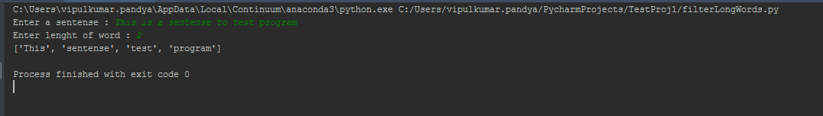

# Problem 2.1

def list_of_int(lst=[]):  
 listOfInt=[len(wrd) for wrd in lst]  
  
 return listOfInt  
  
  
a = input("Enter a sentense : ").split(" ")  
print(list_of_int(a))

Output

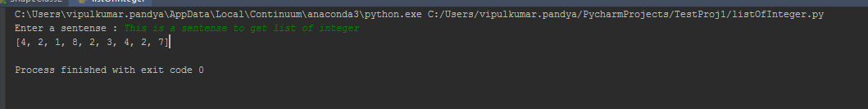

# Problem 2.2

def checkVowel(c):  
 vowel={'a','e','i','o','u'}  
  
 if c.lower() in vowel:  
 return True  
 else:  
 return False  
  
  
  
a=input("Enter a Charater : ")  
print(checkVowel(a))

Output

